Unit: All About Me
Theme: Who am I?
Essential Question: What makes me special?
Focus Question: Who am I?

Vocabulary: special, different, growth, favorite, unique

Materials:
Playdough
Crayons
Tiger & Koala mazes
“All About Me” page
Slant Strokes pages
Self portrait page
Glue
Magazines
Body shape
Scissors
Stickers
Sidewalk chalk

Read Alouds to View:
What I Like About Me by Allia Zobel-Nolan https://www.youtube.com/watch?v=xvWJ0usfiN4
I Like Me by Nancy Carlson https://www.youtube.com/watch?v=VbhUZPA6kwE
Be Who You Are by Todd Parr https://www.youtube.com/watch?v=QGkXyT5tMas
What If We Were All the Same? by C.M. Harris https://www.youtube.com/watch?v=PIR4zZvrOkI
We Are All Alike, We Are All Different by Cheltenham Elementary School Kindergartners
https://www.youtube.com/watch?v=LUhwF4ie8WM

Questions/Discussion Ideas after Read Alouds:
* What makes you special?
* Do you have any of the characteristics from the stories? Freckles, big ears, curly tails, etc?
* Discuss similarities and difference in members of your family (hair color, eye color, height, age, etc)
* Look in magazines or online at images of people. State how they are alike and different.
* Review your child’s full name, age, and birthday!

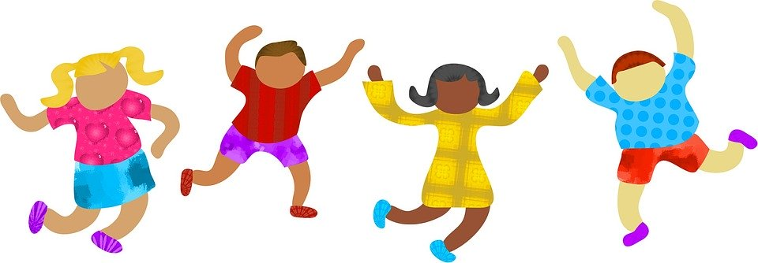

At Home Choice Board: Choose 2 activities to complete each school day!

Have your child use playdough to create their first initial. | Practice writing the slant strokes (see attached) | Watch a video about being different & the same!  https://www.youtube.com/watch?v=hUrjb4SZnxg | Complete the “Tiger” and “Koala” mazes to practice the pull down and slide strokes. (see attached) | Share a baby photo of your child. Discuss how they have changed as they’ve grown. Talk about what they can do now that they could not as a baby. Show your own baby picture.
Practice writing your name! Use crayons to rainbow write: https://www.youtube.com/watch?v=2xh-DYWh1HI  *You can choose your own colors if you don’t have the ones in the video! | Sing a song about your face!  https://www.youtube.com/watch?v=X8jOwEyWTHw | Play a name game to work on syllables!  https://www.youtube.com/watch?v=iJgTL-dKyJk | Decorate the body shape (see attached) with drawings, stickers, and pictures from ads, magazines, or boxes! Cover it with things your child loves! Have them help think of and find pictures. You cut if they aren’t ready, they can glue! | Play “I Spy” for color review! Be sure to include: red, orange, yellow, green, blue, purple, pink, brown, black, white, & gray.  Here’s how:  https://www.youtube.com/watch?v=5ybJXkE0VaY
Practice counting 3 objects in different configurations:  https://www.youtube.com/watch?v=cNRt8dwpb3U | Practice the alphabet with a fun song! https://www.youtube.com/watch?v=iSKcUJOF-Dw | Play a fun movement game: https://www.youtube.com/watch?v=388Q44ReOWE | Complete the “All About Me” page! (See attached) | Draw a self portrait! (See attached)  Or, go outside and draw yourself with chalk!

Unit: All About Me
Theme: My Feelings
Essential Question: What makes me special?
Focus Question: What are my feelings

Vocabulary: feelings, emotions, excited, proud, grumpy, frightened, happy, shy, confused, tired, sleepy, unhappy, sad

Materials:
Playdough
Journal pages: how I feel, things that make me happy, The Little Red Hen (attached)
LTI Practice pages (attached)
Shaving cream
Baking sheet/large plate/ or tray
scissors
Goat maze (attached)
2 paper cups
Pencils
Paper
crayons
Markers
Sometimes book copy (attached)
Dot pages and family pages (attached)

Read Alouds to View:
Lots of Feelings by Shelley Rotner https://www.youtube.com/watch?v=dfDEQao_9oM
You can also listen to a song from the book here: https://www.youtube.com/watch?v=ON7soSL9nfA
The Feelings Book by Todd Parr https://www.youtube.com/watch?v=Wg1ZesqcFcQ
The Color Monster: A Story About Emotions by Anna Llenas https://www.youtube.com/watch?v=PWujGPb6mgo
The Way I Feel by Janan Cain https://www.youtube.com/watch?v=gtTKXuzBh00
How Do You Feel? by Anthony Browne https://www.youtube.com/watch?v=MqrqxufmF1Q

Questions/Discussion Ideas after Read Alouds:
* How do you feel today?
* Discuss how faces look when they are happy, sad, mad, scared, surprised, etc
* Explain that an author writes the story and an illustrator creates the pictures.
* Make a list of things that make you happy, sad, mad, frustrated, etc. Change the emotions to best suit your child.
* Review your child’s full name, age, and birthday!

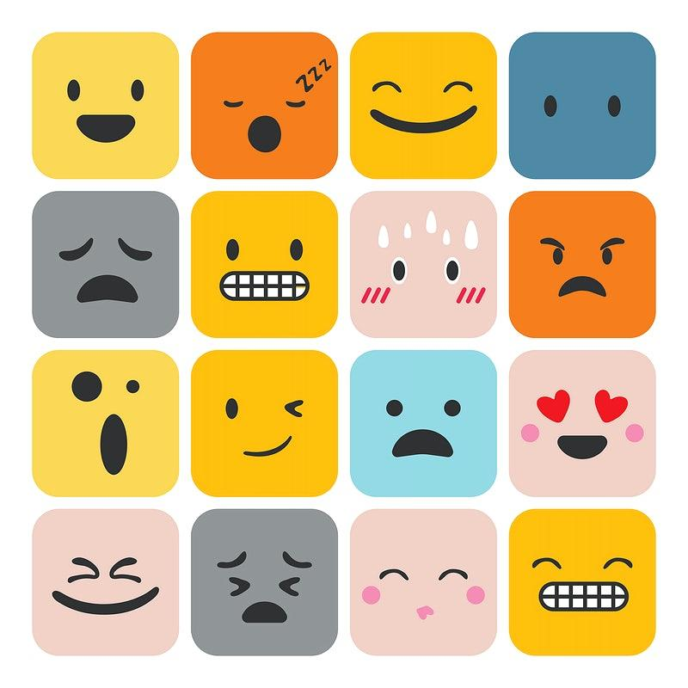

At Home Choice Board: Choose 2 activities to complete each school day!

Talk about how this child looks. Ask how you could make them feel better. | Play an emotion guessing game here:  https://www.youtube.com/watch?v=dOkyKyVFnSs  https://www.youtube.com/watch?v=ZxfJicfyCdg | Listen to a song about feelings:  https://www.youtube.com/watch?v=-J7HcVLsCrY  https://www.youtube.com/watch?v=utZr0dPu5sk | Complete the “Goat” maze to review and practice the circle strokes. (see attached) | Learn about the letters Ll, Tt, and Ii  https://www.youtube.com/watch?v=qEXMoeYe47c  https://www.youtube.com/watch?v=HHEqOLZ0hr4  https://www.youtube.com/watch?v=P56hZEhqFCw
Practice writing your name! Use shaving cream on a plate or tray! https://www.youtube.com/watch?v=NM-KbR6lCDE | Sing “If You’re Happy and You Know It”  https://www.youtube.com/watch?v=WiDRpk9li9I | Listen to The Little Red Hen. Discuss feelings she & the other characters had throughout the story.  https://www.youtube.com/watch?v=2E72TZy0LNo&t=6s | Create a ”Mood of the Day” cup! See how here:  https://www.youtube.com/watch?v=VFKjK9BmY9Q  After, practice snipping or cutting the scraps! | Have your child help set the set or clear the table after a meal together.
Practice using the pull down and slide strokes to write the letters L, T, and I.  After, find items in your house that begin with each letter! | Practice counting the groups of dots. Then, count the people in each family (see attached). Create groups for the families- group of 2, 3, 4, & 5. | Practice counting the math way! Just practice 1-5 for now!  https://www.youtube.com/watch?v=jLs15gS1lX0&t=70s | Make a feelings book. (see attached) | Draw a picture of what makes you happy, how you feel today, or of the story The Little red Hen. (See attached)
Unit: All About Me
Theme: My Body
Essential Question: What makes me special?
Focus Question: What do the parts of the body do?

Vocabulary: body, senses, sight, hear, smell, touch, feel, (specific body part names)

Materials:
Paper
fingerpaint
F, E, & H practice pages
Crayons
pencils
Worm maze (attached)
“My body can” journal page (attached)
Numeral and dot cards (attached)
Lesson 20 math sheet (attached)
Playdough
Numeral math mats (attached)

Read Alouds to View:
A First Book All About You: Eyes, Nose, Fingers, and Toes by Judy Hindley https://www.youtube.com/watch?v=OQkUhijF41I
Here are My Hands by Bill Martin, Jr. & John Archembault https://www.youtube.com/watch?v=9R8nwkw6kFU
Nose to Toes by Marilyn Baillie https://www.youtube.com/watch?v=D2tew6dQZwE
Look, Listen, Taste, Touch, & Smell: Learning ABout Your Five Senses by Pamela Hill Nettleton
https://www.youtube.com/watch?v=GNqe-6QAew0
It’s Okay to Be Different by Todd Parr https://www.youtube.com/watch?v=7EtevpudIXw

Questions/Discussion Ideas after Read Alouds:
* What body parts do you have?
* What does each part do for you?
* Practice naming body parts, including elbows, shoulders, ankles, wrists, etc,
*What are your 5 senses? Which body parts help us see, hear, feel, taste, and smell?
* How many senses are you using when you eat dinner? Play outside? Swim? Read a book?

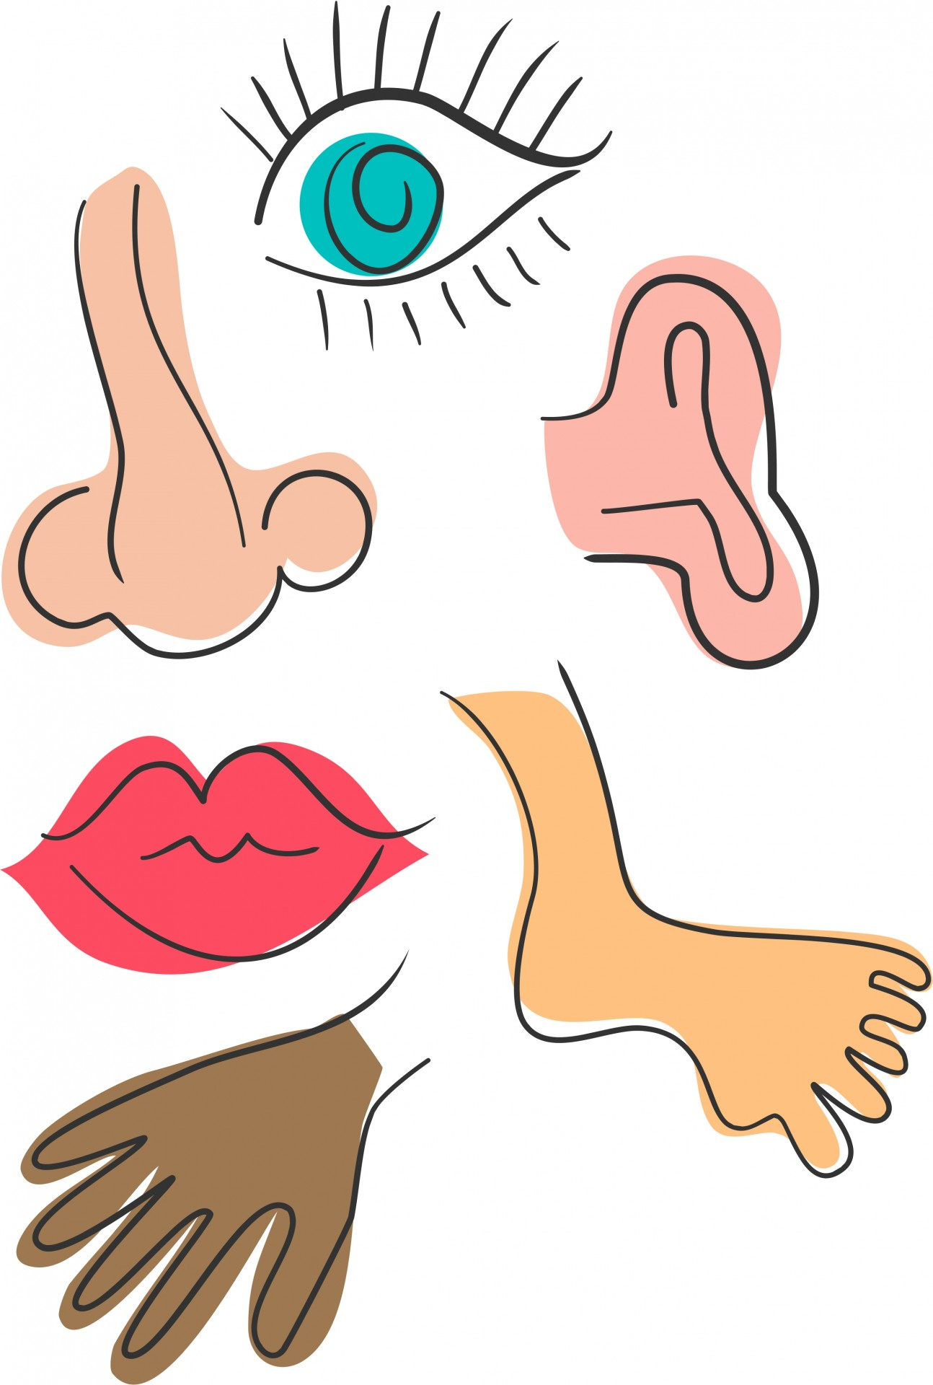

At Home Choice Board: Choose 2 activities to complete each school day!

Learn about the letters F, E, and H!  https://www.youtube.com/watch?v=Zrj0feSC5oo  https://www.youtube.com/watch?v=beaUUPPUT2Y  https://www.youtube.com/watch?v=NtUSMBzacQ0 | Practice writing the letters F, E, & H. Remember to pull down and slide! (see attached)  After, find things in books, magazines, or on TV that begin with each letter! | Watch a video about body parts then see how many your child can name:  https://www.youtube.com/watch?v=iQxOjZ5EPBM | Complete the “Worm” maze to practice the slant strokes. (see attached) | Review shapes with this game:  https://www.youtube.com/watch?v=svrkthG2950&t=43s
Practice writing your name! Use fingerpaint!  If not ready for the whole name, start with the first initial! | Sing a silly version of “Head, Shoulders, Knees, & Toes”  https://www.youtube.com/watch?v=TSdeIhmv6v0 | Practice identifying numerals 1-5 using the mats attached. Have your child make a playdough number then a matching set of playdough balls. | Practice scissor skills with a silly haircut craft. Cut vertical slits into an empty toilet paper tube. Have your child create a face & give it a “haircut.”  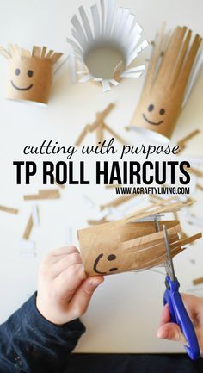 | Play “I Spy” for textures! I spy something smooth, bumpy, hard, soft, etc,  Here’s how to play:  https://www.youtube.com/watch?v=5ybJXkE0VaY
Play a name game!  https://www.youtube.com/watch?v=OzKY5YHnOTg | Have your child touch and count each set on the lesson 20 worksheet (attached). Color the sets that have 5. | Show a numeral or dot card and have your child give you that many objects from home (cereal, pennies, toys, etc) | Make a face snack! Use fruit on pancakes, a rice cake with raisins, or make a pizza face! | Draw a self portrait! Label body parts and write down what your child can do with each!(See attached)
Unit: All About Me
Theme: My Family
Essential Question: What makes me special?
Focus Question: What is a family?

Vocabulary: family, mother, father, brother, sister, step, tradition, family members, grandparents

Materials:
O & Q practice pages
Crayons
Box
Magazines
Paper
Glue
scissors
“My Family” journal page (attached)
Baking sheet or tray
Salt
Number Book (attached)

Read Alouds to View:
Saturday by Oge Mora https://www.youtube.com/watch?v=iURjU8JJ1ek
Love Makes a Family by Sophie Beer https://www.youtube.com/watch?v=yzTNWAjZS6M
Families, Families, Families! by Suzanne Lang and Max Lang https://www.youtube.com/watch?v=a2GAPlHXAkk
This Is My Family by Gina and Mercer Mayer https://www.youtube.com/watch?v=6NeKTgoF07s
The Family Book by Todd Parr https://www.youtube.com/watch?v=AyVL9bH0guk

Questions/Discussion Ideas after Read Alouds:
* What is a family?
*Who can be in a family?
*Who is in your family?
* How does your family work, play, and celebrate together?
*Are all families the same?

At Home Choice Board: Choose 2 activities to complete each school day!

Learn about the letters O and Q:  https://www.youtube.com/watch?v=oWbY5EKys60  https://www.youtube.com/watch?v=NKAookrRV4s | Practice writing the letters O & Q.  Remember to circle back and slant right for the Q (see attached) | Listen to a song about families:  https://www.youtube.com/watch?v=ii_LtHrEiao  or  https://www.youtube.com/watch?v=foptl0BeXnY | Make a simple family tree or a chart that states:  Families can…  Families are…  Families have…. | Have a family game night!
Practice writing your name! Make a salt tray! Here’s how:  https://www.youtube.com/watch?v=Il9ZtprBnsc  If not ready for the whole name, start with the first initial! | Watch an ASL reading of Five Little Monkeys Jumping on the Bed.  https://www.youtube.com/watch?v=yGdISmwi1tA  Review the 5 senses. Retell the story aloud after viewing! | Practice the alphabet with this song:  https://www.youtube.com/watch?v=OxrUgwVbqoM | Have your child help with simple chores- make their bed, put away clothing, sort socks, etc. | Review colors:  https://www.youtube.com/watch?v=wmsjmTUVHmc  After each color in the song, have your child something in your home that is the same color!
Continue to show number cards and dots for your child to count/identify and give you that many objects. | Create a number book for numbers 1-5. Color objects that match each number on the pages. (see attached) | Make a simple shape house. Draw a square and a triangle for your child to cut. They glue it together and add a door, windows, etc. | Use an empty box and create a doll house. Use magazine pictures to decorate. | Draw a family portrait! Label each person that lives with you! Discuss the relationship to your child. (See attached)

ALL ABOUT ME READING LOG
Read a story EVERY DAY!! Draw a star or smiley face or place a sticker on the date when done!

September/ October
27 | 28 | 29 | 30 | 1 | 2 | 3
4 | 5 | 6 | 7 | 8 | 9 | 10
11 | 12 | 13 | 14 | 15 | 16 | 17
18 | 19 | 20 | 21 | 22 | 23 | 24

Math Lessons:
***Click on the links below to see full lessons and activities to support the skills.**

All About Me- Who Am I?
https://www.engageny.org/resource/prekindergarten-mathematics-module-1-topic-c-lesson-10
https://www.engageny.org/resource/prekindergarten-mathematics-module-1-topic-c-lesson-11
https://www.engageny.org/resource/prekindergarten-mathematics-module-1-topic-d-lesson-12
https://www.engageny.org/resource/prekindergarten-mathematics-module-1-topic-d-lesson-13
https://www.engageny.org/resource/prekindergarten-mathematics-module-1-topic-d-lesson-14

All About Me- What Are My Feelings?
(see attached Family Letter for at home learning ideas and information)
https://www.engageny.org/resource/prekindergarten-mathematics-module-1-topic-e-lesson-15
https://www.engageny.org/resource/prekindergarten-mathematics-module-1-topic-e-lesson-16
https://www.engageny.org/resource/prekindergarten-mathematics-module-1-topic-e-lesson-17
https://www.engageny.org/resource/prekindergarten-mathematics-module-1-topic-e-lesson-18
https://www.engageny.org/resource/prekindergarten-mathematics-module-1-topic-e-lesson-19

All About Me- My Body
https://www.engageny.org/resource/prekindergarten-mathematics-module-1-topic-e-lesson-20
https://www.engageny.org/resource/prekindergarten-mathematics-module-1-topic-f-lesson-21
https://www.engageny.org/resource/prekindergarten-mathematics-module-1-topic-f-lesson-22
https://www.engageny.org/resource/prekindergarten-mathematics-module-1-topic-f-lesson-23
https://www.engageny.org/resource/prekindergarten-mathematics-module-1-topic-f-lesson-24

All About Me- My Family
https://www.engageny.org/resource/prekindergarten-mathematics-module-1-topic-f-lesson-25
https://www.engageny.org/resource/prekindergarten-mathematics-module-1-topic-f-lesson-26
https://www.engageny.org/resource/prekindergarten-mathematics-module-1-topic-f-lesson-27

